Please send bookings to:-
Hinckley Choral Union
116 Westfield Road
Hinckley
LE10 0LU

or return by email to
hinckleychoralunion@gmail.com

Hinckley Choral Union
Registered Charity
Number 1154110
Telephone 07792 836111

HCU’s next concert:
Saturday 13th April 2019

Beethoven’s Mass in C

Choir, soloists and the
University of Leicester
Sinfonia

7.30pm
United Reformed Church
23 The Borough
Hinckley LE10 1NL

Admission: £12.00
(accompanied under 16’s free)

Venue Location:

United Reformed Church
23 The Borough
Hinckley LE10 1NL

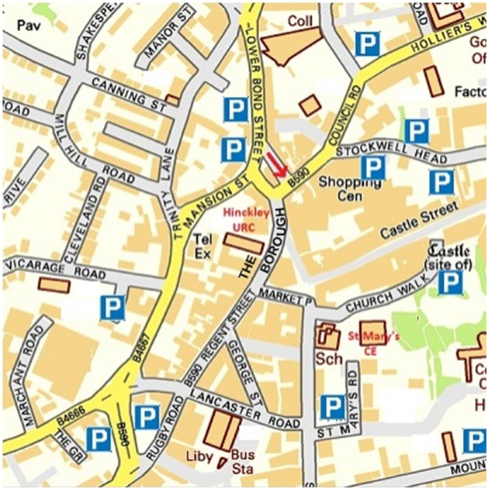

Hinckley Choral Union
invite you to

Come and Sing

Rossini’s
Petite Messe Solennelle
(the chorus movements)

on
Saturday 2nd February 2019
09.30 – 17.30
at
The United Reformed Church
23 The Borough
Hinckley LE10 1NL

Registration £15 for the day (£7.50 for full time students under 25), to include music hire and refreshments

Hinckley Choral Society (re-formed as Hinckley Choral Union in 1966) came into being in October 1907 and has performed concerts nearly every year since. These have covered the major choral works, new pieces and some especially commissioned works. Guest soloists in the past have included Isobel Baillie and Kathleen Ferrier. We are committed to promoting singing for all, and no auditions are held to join the choir.
We held our first Come and Sing (Jenkins’s The Armed Man) last year and it was a great success. For this one, again we will be led by Richard Archer, our musical director. Richard is one of the best known figures in Leicestershire musical circles. He has been our MD for 40 years (so he must think highly of us!), as well as conducting the City of Leicester Singers and the Jubilee singers and being musical director at St John the Baptist, Leicester. He is a Fellow of the Royal College of Organists and holds the Archbishop’s Diploma in Church Music. Our accompanist for the day will be Alec McGregor.
Rossini's Petite Messe Solennelle was written in 1863,. The composer, who had retired from composing operas more than 30 years before, described it as "the last of my péchés de vieillesse" (sins of old age). The work is neither petite or, despite being based on the Latin Mass, that solemn as it carries more than a passing reference to Rossini’s most well known musical genres, those of grand and comic operas as we shall discover when we sing those wonderful choruses.

Timetable
9:30 - Registration & distribution of scores
Tea/Coffee,
10:00 - 11:00 Rehearsal Session 1
11:00 - 11:20 Break
11:20 - 12:20 Rehearsal Session 2

12:20 - 13:10 Lunch Break -

please bring a packed lunch.
Tea/coffee provided

13:10 - 14:10 Rehearsal Session 3
14:10 - 14:30 Break
14:30 - 15:30 Rehearsal Session 4
15:30 - 16:30 Afternoon Tea (and cakes!)

16:30 - 17:15 Performance
17:15 - Return of scores and departure
o-o-o-o-o-o
Please invite your family and friends to the tea and performance to hear the fruits of your day’s labour! Admission is free: there will be a donation box in aid of a local charity.

Booking form (please detach and send in).
You may use this for more than one singer –
please give voice part for each name.

Please reserve [ ] place(s) @£15 pp for HCU’s
Come and Sing: Rossini’s Petite Messe Solonnelle
on Saturday 2nd Feb 2019.

I enclose payment £

Name(s)

Soprano …………………………………….

Alto ………………………………………….

Tenor ………………………………………..

Bass ………………………………………….

Contact telephone/mobile number:
Email:

Address (optional - if you prefer over email):

Do you have a disability or impairment
which we should know about?

Please see overleaf for address to send this form to

Cheques payable to Hinckley Choral Union
or pay by Bank Transfer to
Account No: 07529589 Sort code: 60 11 06
When making payment please quote reference CS2019 followed by name or person making the booking

